 |  | AI Governance: White Paper Series |  | October 2025
 |  | Part 3. Ethical Oversight and Governance Bodies in AI: Guarding the Creators.
INSIDE  __  Deep Dive into Governance component #2:  AI Ethics Policy, Governance Committee, and Lifecycle Oversight  __  New research in the spotlight  We highlight some of the latest research on the topic |  | 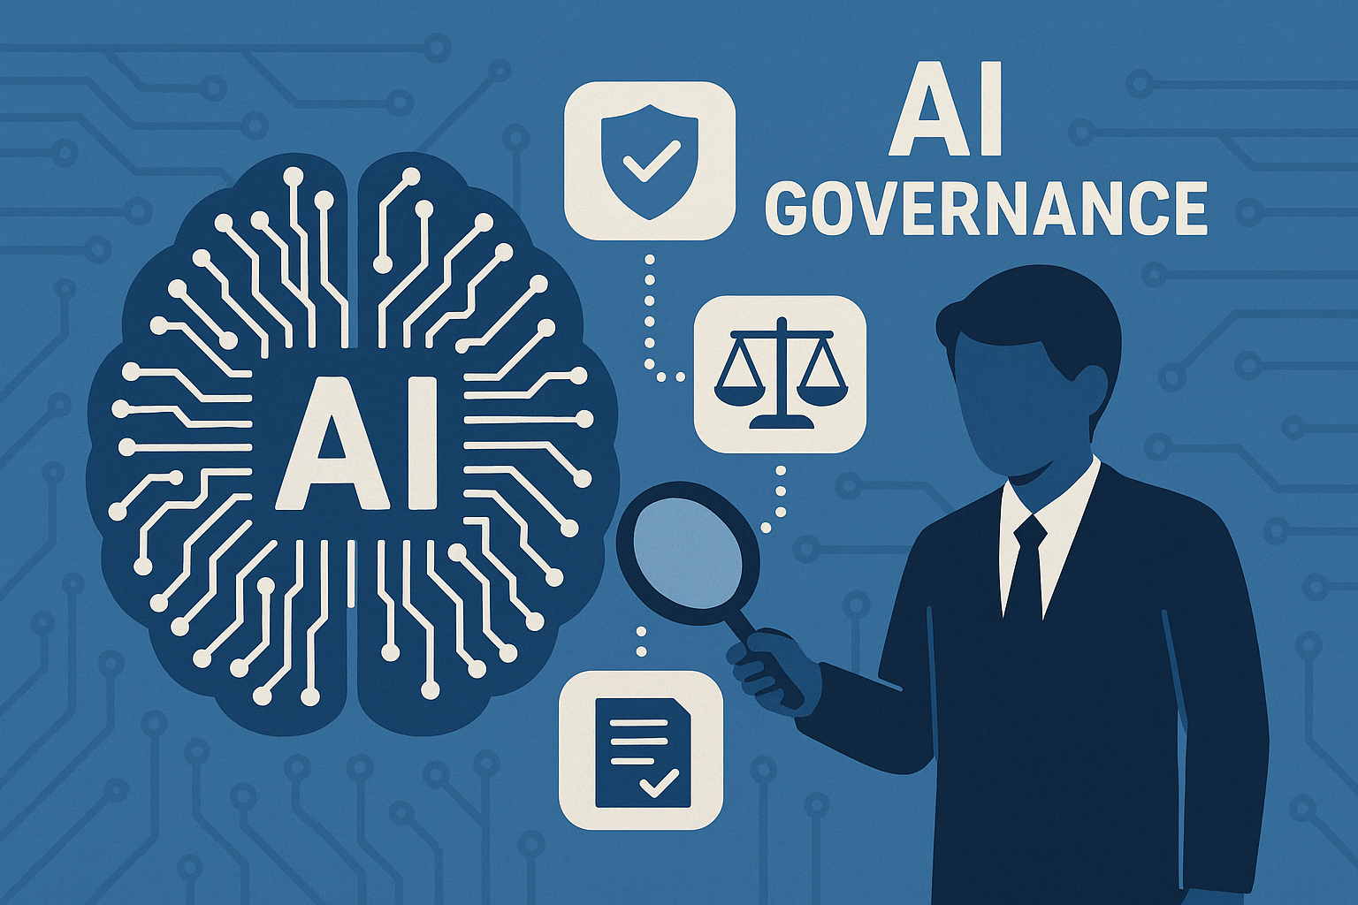
Authors |  | Julia Vitte  Director, risk management expert, conducting her research at VU Amsterdam.  j.vitte@vu.nl | Jost Sieweke  Director, Associate Professor at  VU Amsterdam.  j.sieweke@vu.nl
Ronald van der Wal
Partner, Risk Management, Compliance and Integrity, CPI Risk Finance Governance
rvanderwal@meetcpi.com

In this Whitepaper, we further explore AI governance, focusing on establishment of the AI governance Framework.

We focus on the three key elements of any governance framework:

We also would like to explore which existing elements could be used for AI oversight, if oversight activities are not yet in place.

*An AI-system lifecycle typically involves several phases:
- planning and design,
- data collection and processing,
- model building and/or adapting existing models to specific tasks,
- testing, evaluation, verification and validation,
- deployment, and
- operation and monitoring.

Research

AI and its oversight are relatively new concepts, and we are curious about what we know about it from research.

Birkstedt et al. (2023) define internal AI Governance as the "system of rules, practices, and processes to ensure AI use aligns with organizational strategies, values, legal and ethical obligations".
Scientific community discusses the following 4 key topics on AI governance:
- Governance is lagging AI innovation.
- Ethical guidelines are important, but insufficient without enforcement.
- Big Tech power must be balanced with public interests.
- AI-specific regulatory frameworks must go beyond analogies with older technologies.

There is also an agreement that companies benefit from cross-functional ethics committees and direct involvement of the Board in AI oversight (Ganesh et al., 2025; Birkstedt et al., 2023; Sigfrids et al., 2022).
Research also notes that many existing frameworks remain at a conceptual level. Few have been empirically validated or provide detailed guidance on enforcement and monitoring (Birkstedt et al., 2023) – which of course makes sense considering how young the field is.
“Principles alone are too abstract; organizations must operationalize them with measurable targets.”
— Gianni et al., 2022

These findings, combined with the market practice, motivate us to explore ways to bridge the gap between high-level principles and actionable, measurable governance.

Practical adoption
In this Whitepaper, we focus on the three governance components: a policy (or a set of documents, depending on company need); an oversight body (a new or existing committee), and a strong oversight process.

A Policy

A good policy has a certain number of attributes to make it concrete, linked to the organization’s needs, and implementable. We propose that a Policy:

A strong policy has regulatory requirements as its basis. Regulations often provide a normative framework, suggesting best practices for designing, deploying, and monitoring AI systems.

Regulatory bodies are working on AI oversight guidelines. Furthermore, ethical guidelines are emerging as part of the broader conversation on AI governance, emphasizing principles such as fairness, non-maleficence, privacy, and accountability. So, there is no shortage of information from regulators and research centers like ours to derive policy content from.

Building on the research findings and regulatory framework, we strongly advise to include the following requirements in a policy:
- Requirements to prevent Algorithmic Bias: Discriminatory outcomes can arise when AI models, trained on historical data or flawed assumptions, inadvertently reinforce or exacerbate biases. This issue is central to the modern debate on AI ethics, as biased algorithms can affect recruitment, lending, policing, and healthcare decisions.
- Overcoming Transparency Deficits: Often described as the “black box” problem, many AI systems do not provide adequate explanations for their decisions. This opacity hampers accountability, making it difficult for stakeholders to understand, trust, or contest AI-driven decisions. Therefore, building a framework for explainable AI is a strong next step.

Accountability: When harm or errors occur as a result of automated decisions, establishing clear lines of responsibility is challenging. Traditional legal and regulatory systems may not be well-equipped to assign liability in cases where AI is involved. We recommend that companies develop clear accountability and responsibility structures when it comes to AI development and use.
Ronald van der Wal comments:
Any document which governs AI lifecycle needs to be taken with the breadth of stakeholders in mind. My advice would be. do not incorporate AI management into an existing IT policy. Rather treat it as a separate topic, which includes multiple stakeholders – think HR and marketing, as well as multiple other users of AI, next to an IT team. Another suggestion is to describe AI-related governance as clearly as possible, so that all employees understand it. This topic really touches on everyone.

An oversight body

A governance committee is a cornerstone of every organisation’s approach to AI
oversight. First and foremost: an oversight body, be it an existing or a newly created committee, must be multidisciplinary.
It is key to get the whole team of experts in the room: IT, legal, risk& compliance, data science, HR, and business units to grasp the complexity of AI systems.

As a minimum, the committee needs to be in charge of:
- Reviewing and approving new AI uses, to align company values and risk behaviour;
- Addressing regulatory requirements and control regulatory compliance;
- Align AI use with business objectives and value generation;
- Make sure there is enough human oversight in AI development, implementation and use;
- For major AI initiatives – both new and those already in use – assess feasibility, set goals, and confirm alignment with ethics policies and business strategy;
- Oversee data quality, representativeness, and compliance with privacy regulations, if this is not done by an existing Committee;
- Testing, Evaluation, and Validation of AI models - Verify technical performance and compliance before deployment;
- Oversee effectiveness of controls and monitoring procedures;
- Continuously track performance, address incidents, and take decisions on retiring systems responsibly when necessary.

For each company, there is a choice to be made: either use existing or establish new governance structures. Organisations can choose to integrate AI governance responsibilities into existing bodies, such as enterprise risk or compliance committees. This approach reduces cost, duplications, and adds AI considerations into the broader governance culture.
However, this would be most feasible for financial services companies, which are already supervised and used to oversight committees. For example, existing models are already managed and controlled by a dedicated committee and AI models can then be absorbed in its mandate.
Ronald van der Wal comments:
I am always advising to make oversight leaner and less bureaucratic. However, the topic requires equal parts of open-mindedness and readiness to experiment, and in the same time – oversight needs to have enough organizational weight. Neither freedom nor over-regulation are healthy, and we need to strive for a balance.
In terms of hierarchy – the oversight body does not have to be very high in the organization, but absolutely must cover a wide range of functions. Rather than a rigid approval structure, the focus should be on learning and sharing of the information next to oversight activities.

An oversight process
We propose 2 key principles for a robust oversight process:
- Oversight should cover the whole AI lifecycle and
- Oversight should be proportionate to the importance and risk classification of the AI system

Below, we also propose a series of actions which will cater for a strong governance process.

Action | Outcome

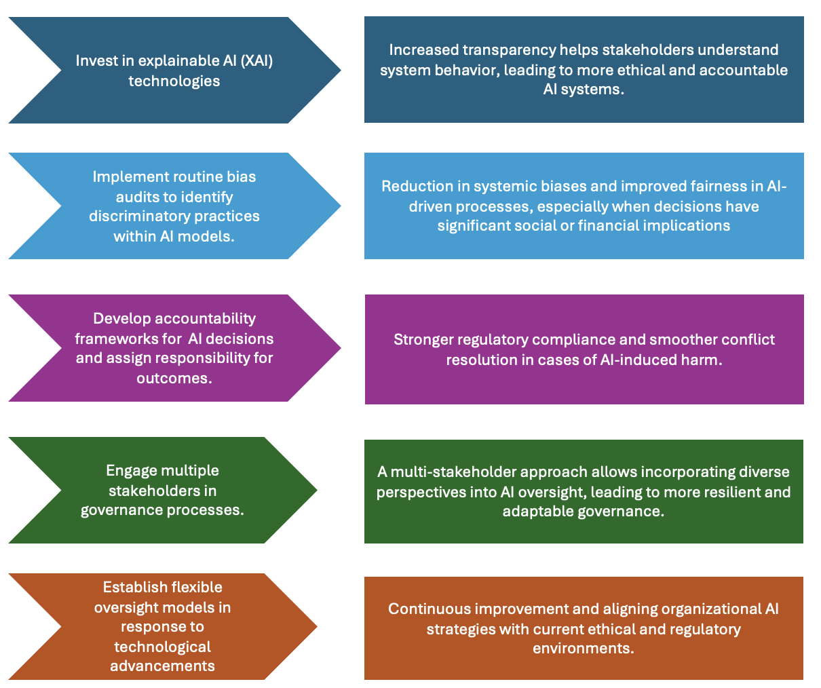

Top 3 key points for a strong governance process from Ronald van der Wal:
- Enthusiasm – people need to be open for both using AI and controlling what AI does, and have information on the usage is very important
- Organizations must stay up to date with knowledge on controlled operations – don’t let it become a black box people don’t trust.
- Current speed of development is extremely high. Perhaps organizations could dedicate a specific role or a resource to monitoring AI developments, to avoid becoming outdated..
AI gives organizations a lot of advantages, but they also need to invest in it – in people, in their knowledge, and in their dedication.

In summary
This third paper in the AI Governance White Paper Series shows how organizations can establish an effective AI governance framework. Building on our earlier work, we focus on three practical components: defining an AI policy, setting up a multidisciplinary governance committee, and ensuring oversight across the entire AI lifecycle. Drawing on recent research and regulatory guidance, including the EU AI Act, we shed light on how these elements provide structure, accountability, and transparency.

Key Citations:
- Taeihagh, A. (2025). Governance of Generative AI. Policy and Society, 44(1), 1–22.
- Ulnicane, I. (2024). Governance Fix? Policy and Society, 44(1), 70–84.
- Birkstedt, T., et al. (2023). AI Governance: Themes, Gaps, Agendas. Internet Research, 33(7), 133.
- Gianni, R., et al. (2022). Governance of Responsible AI: From Ethical Guidelines to Cooperative Policies. Frontiers in Computer Science.
- McEvoy, F. J. (2019). Political machines: Ethical Governance in the Age of AI. Moral Philosophy and Politics.

About us

VU Risk and Crisis Management knowledge hub is a dedicated space for industry practitioners and academics to connect with each other. We have created it in response to growing global uncertainty, as well a disconnect we noticed between industry practices and latest research.

You can find more on our website and LinkedIn.

 | 
Julia Vitte  Director, risk management expert, conducting her research at VU Amsterdam.  j.vitte@vu.nl | Jost Sieweke  Director and Associate Professor, VU Amsterdam.  j.sieweke@vu.nl

Ronald van der Wal

Partner, Risk Management, Compliance and Integrity
CPI Risk Finance Governance
rvanderwal@meetcpi.com

